Model: (5x5) eg. 54925-68801

Jabil SN: eg. MY20040001

Failure Mode: (scratches, dent, discolouration and etc)

Allowed cosmetic tolerance:

|  |  |  |
| --- | --- | --- |
| Class | T & D | Measurements |
| II-A | 10s (45cm) | 0.5mm |
| II-B | 5s (45cm) | 0.5mm |

Information from operation:

1. Operator Name:
2. Total Duration:
3. Failed times:

Image:

Front DUT (eg)

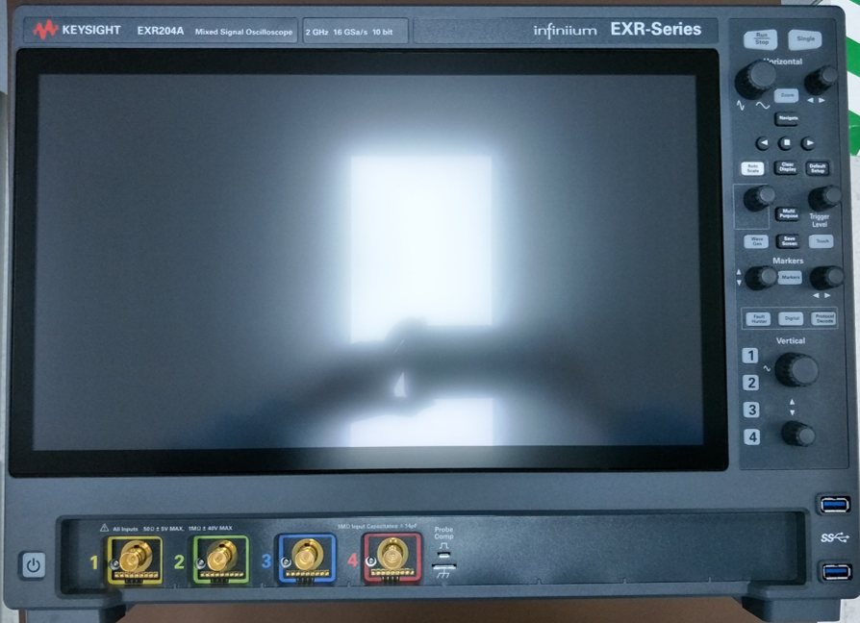

Back DUT (eg)

Failed area (eg)

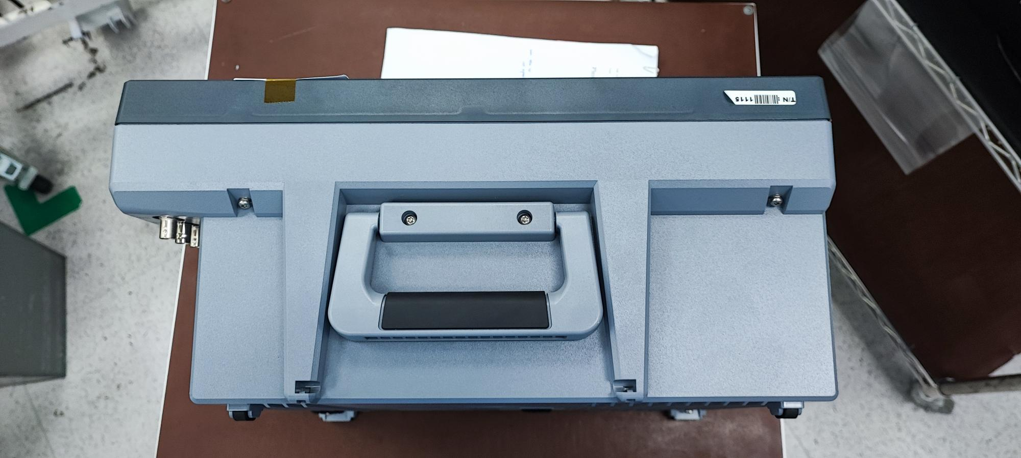

Force applied:

|  |  |  |
| --- | --- | --- |
| No | Button | Force (N) |
| 1 | Pushbutton | XX.X |
| 2 | Knob | XX.X |

*\*Note: For the file name should follow this format (“Model number” “Jabil SN”) eg. 54925-68801 MY20040001*